WIZnet iEthernet Design Contest 2007
Complete Documentation
Entry number 001153
Chuck Baird, service <at> cbaird.net

AVR Flash Loader

Introduction
This project (001153) uses a WIZnet WIZ810MJ board to implement an ethernet based automatic flash and EEPROM programmer for the Atmel Butterfly development board. The Atmel Butterfly was chosen because of its low price (under $25) and complement of existing support circuitry, thus allowing the entire project to be constructed from off the shelf components and a wiring harness. However, because of design consistency across the AVR product line, the project could easily be ported to the majority of the AVR microcontrollers with very minimal changes to the software.
A manual mode of operation is also implemented, allowing the user to fully control the programming process. However, in automatic mode no user interaction on the PC side is needed.
The code for this project exists within the Butterfly as a protected bootloader (written in assembly language), independent of any resident Butterfly application. The PC server application was written in Visual Basic 6.
When the Butterfly is powered on or reset it attempts to initialize the WIZnet board and make a client TCP connection to the host software. If it is unsuccessful, or if the Butterfly’s application program has disabled the bootloader, program execution jumps to the resident application in the Butterfly.
If the TCP connection to the host PC software is successful, there are different options depending on the PC user’s settings in the server application. In automatic (unattended) mode, download of a specified Intel hex file to the EEPROM and/or flash memory of the Butterfly, with verify, will be initiated. In manual mode, the user may read and/or write the Butterfly’s flash or EEPROM memories, edit the memory images, and save or load them to and from disk files as Intel hex or ASCII dump files.
In both modes the memory image may also be automatically modified (for serial number sequencing, insertion of different text strings, etc.) via simple scripting commands. Thus the resulting firmware in each programmed Butterfly can be different, even in unattended operation.
This facilitates bulk, automated programming with unique results. Once the Butterfly has been initially programmed with the bootloader using standard tools, bulk programming can take place in a production environment via the flexibility of the ethernet connection. The WIZnet board may continue to be a part of the Butterfly’s application, or may be removed except during programming.
The Butterfly is based on an 8MHz ATmega169 MCU with 16K flash, 2K SRAM, 512 bytes EEPROM, 4MB dataflash, 6 character LCD, joystick, and other peripherals. The WIZ810MJ board is accessed using its SPI mode, given the Butterfly has an SPI header readily available and a shortage of available I/O pins. The full resources of the ATmega169, and the Butterfly itself, are barely utilized in this application.

Operation – Manual Mode
The PC server application is run first, and the user selects either manual (default) or automatic mode using the AutoLoader frame option buttons.
In manual mode the user works with a memory image displayed as an ASCII dump (hex address, hex contents, ASCII contents). This may be a flash image (16K bytes) or an EEPROM image (512 bytes). The user may load an image from an Intel hex file, an ASCII dump file previously saved, or from the Butterfly itself. Editing is also possible, described below.
Figure 1 shows an example of manual mode, where the Butterfly flash was read, then verified, by clicking the corresponding buttons in the Manual Connection frame.

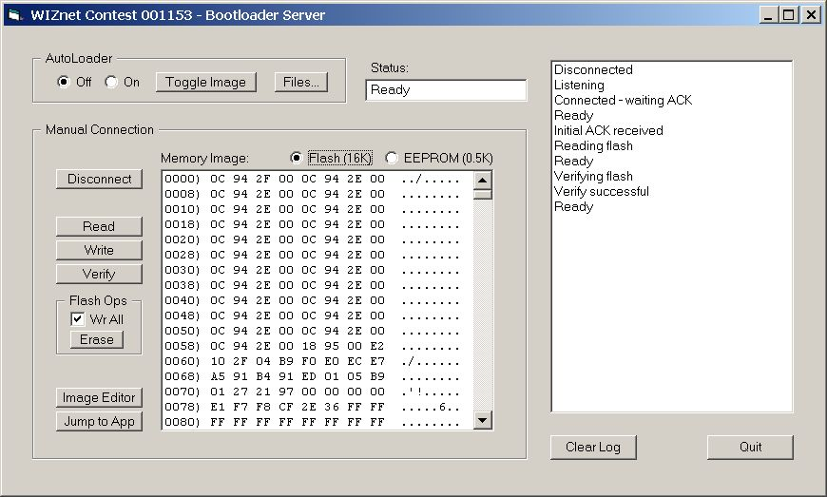
Figure 1 – Main server screen

The user may also cause the Butterfly to execute its application code when in manual mode. This will close the TCP connection since the client bootloader will no longer be running.
In manual mode, the AutoLoader Files... button is enabled. This allows the user to specify which files are to be used in the automatic flash and/or EEPROM programming.

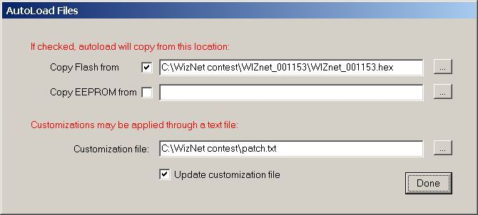
Figure 2 – Files for automatic mode

An Intel hex file (*.hex or *.eep) may be specified for the flash and EEPROM programming, with checkboxes selecting their use. A customization file may be specified which allows for patching either or both of the hex files. This is a text file which may include both static and dynamic patches, that is, values which do or do not change for each patch as it is applied. If the Update box is checked, the dynamic patches will be modified in the text file. Changes on this screen persist and are maintained in an ini file.

Autoloader (Automatic) Mode
If the autoloader option is on, when a TCP connection from the Butterfly to the server is made, the specified files are read, patched if appropriate, and then written and verified to the Butterfly. A jump to the Butterfly’s loaded application is then executed, and the server software resets for the next connection request. No user intervention is required.
Figure 3 shows a typical automatic mode session using the files as shown in Figure 2.

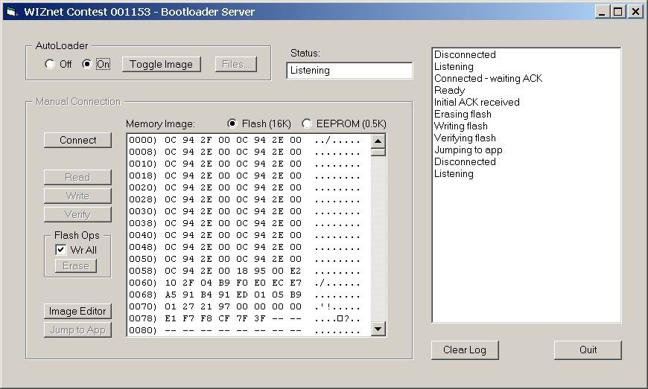
Figure 3 – Automatic mode

The log shows the sequence: flash is erased, the hex file is written and verified, and then the Butterfly’s bootloader is exited by jumping to the application code. The TCP connection is closed, and then reopened, waiting for the next connection.

Memory Image Editor
In manual mode there is a memory image editor that may be used to load, save, edit, or patch the memory contents.
Once the image is as desired, it may be written and/or verified to the Butterfly. The user may also initiate a jump to the Butterfly’s resident application from its bootloader.

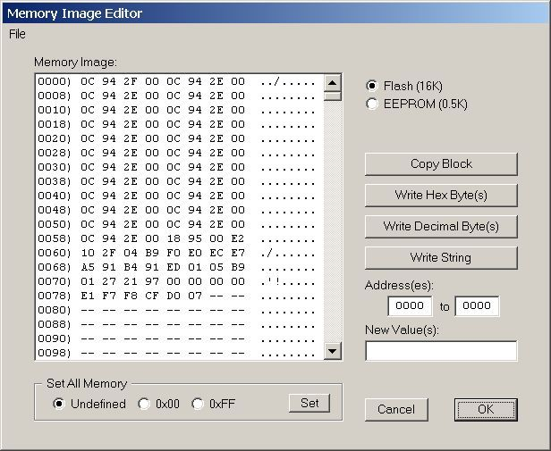
Figure 4 – Image editor

Hex, decimal, and string values may be edited into the image, and blocks of values may be copied to other locations. Through the File menu, Intel hex and ASCII dump (the displayed format) files may be saved, loaded, or merged into the image. Customizations may also be applied, with or without updates to the customization file.
Undefined values are displayed as --. These result from “holes” in the hex file and represent unused memory. They will not write to a hex file or EEPROM, and will write as 0xFF to flash (in manual mode, if the Write All box is unchecked, pages containing nothing but undefined values are not written to flash). For flash memory undefined values will verify as 0xFF (an unprogrammed value), and for EEPROM the corresponding memory location will be ignored during verify.

Customization Commands
The customization file is a text file (extension .txt) which implements a simple scripting language. Each line designates a patch of one or more bytes, either to flash or EEPROM. There are static patches, which do not change, and dynamic patches which are updated if the user has indicated to do so.
The first character is C or S (for change or static), and the second character is E or F (for EEPROM or Flash). The next 4 characters are the address, in hexadecimal.
For strings, this complete the definition of the header line. One (for static) or more (for dynamic) lines containing strings follow, the first character of which is >. When a dynamic string is updated, the > is replaced with *, indicating the string has been applied. Leading and trailing blanks are significant in the strings and are applied as patches.
For numbers, the 7th character is a space. Following that, for static numbers there is a comma delimited list of decimal or hex (with leading 0x) numbers with no embedded blanks. Values must be 0 to 255.
For dynamic numbers, 3 comma delimited values follow the space in column 7. The first is the number of bytes the number is to occupy, maximum of 4. The second number, which gets updated, is the current value. The third number is the increment value (in this version, positive only). The value will top out at the maximum (255, 65535, etc.) or 99,999,999 for 4 bytes.
The byte order for storing a multibyte dynamic number can be specified with a separate command. Its format (and default value) is Byteorder=12,123,1234 and must be followed exactly. The numbers between the commas indicate the storing order for 2, 3, and 4 byte values. As shown, the low order byte of the each sized value will be stored in the first position, the next lowest order byte will be stored in the second position, etc. The byteorder command may appear multiple times, and the most recent one will be in effect at any time.
Here is an example of a customization file:

; patch EEPROM at 0000 - 0002
SE0000 0x2a,123,0
; patch flash at 0004 - 0007
SF0004
>Test
>ignored
; patch flash 0010-0013 with 123, 135, etc.
CF0010 4,123,12
; patch flash with different strings
CF0020
*this one is done
>next one to do
>one after that
Figure 5 – Customization file

Lines (other than Byteorder) that do not start with C, c, S, s, or > are ignored. Patches are applied in the order they appear and may overlap each other.

Server – Client Commands
The connection between the client and server uses TCP. The following commands are implemented:

Command | Initiates | Function
E addr count <data> | server | Write bytes to EEPROM
F page <data> | server | Write page to Flash
A | client | Ack
e page | server | Read page of EEPROM
f page | server | Read page of Flash
<data> | client | Returned data (response to e or f)
X | server | Erase flash
J | server | Jump to application
Figure 6 – Commands

This is a simple command structure, sufficient to handle the tasks as implemented. In a more robust application it should be supplemented with various error protection and reporting techniques, etc. All flash references are to the application portion of flash, below the bootloader (which starts at 0x1C00). All of EEPROM is accessible.
Notes:
The client sends an Ack after the connection is established and it is ready to communicate.
All commands other than Ack receive an Ack or <data> response.
Pages are numbered 0-111 for flash, and 0-3 for EEPROM.
Pages are 64 words (128 bytes) long.
EEPROM addresses are 0 - 511. Written data is limited to 128 bytes at a time (“E” command).
EEPROM addresses (“E” command) are 2 bytes, high order first.
Page numbers are 1 byte.
Maximum message length from client to host is 128 bytes.
Maximum message length from host to client is 132 bytes.
<data> is usually 128 bytes, but can be less for EEPROM writes.
The J command from the server receives an Ack, at which time both sides shut down the TCP connection.

The Problems
There were certain problems, or shall we say educational opportunities, that arose during the construction of this project. While the WizNet documentation could have been better it was sufficient and the product is certainly easy to use. This was the author’s first attempt at embedded ethernet applications, and there was a certain lack of experience at play here.
The project works as described, and a simple test was devised. The Butterfly code shown below includes a small application (existing below address 0x1C00 where the bootloader code starts) that uses a simple loop to generate a tone on the Butterfly’s piezo element. A patch file was created with one entry to alter the loop constant, thus altering the tone. The idea was that the server software would be run, and the Butterfly repeatedly attached to the ethernet cable and powered on. On each attachment it would be reprogrammed with a different loop constant, and thus each time (when the bootloader exited to the application code) a different tone would be heard. All this should occur without any user intervention on the server side.
And it worked, with a small caveat. There is some sort of delay or setup time, not understood by the author, that prevents the TCP connection being remade very quickly once it is closed. This appears to be a Windows XP quirk (or design feature), since many things were tried (modifying routers, firewalls, timing delays in the Butterfly’s bootloader, etc.) without changing the pattern. The Visual Basic Winsock control is simplicity itself and has no provision for sophisticated manipulation: you see a connection request, you open it, you read and write data, you close it. In reality there’s also a “you wait a minute or more between connections” feature that isn’t documented.
But overall things progressed smoothly. The performance of the flash programming was good – about a second for a 14K erase, write, and verify. All in all it was an interesting and entertaining project.

Block Diagram
Because of the slightly unusual spacing of the header pins (2 mm) on the WIZ810MJ, an inexpensive SPI breakout board was purchased from www.nkcelectronics.com. This board, fully populated, also provided a reset switch, power LED, and LEDs for the 5 status signals, all with pullup resistors. The SPI and other signals are brought out to a more convenient 0.1” header.
In addition, the board has support for an internal pullup to Vcc for the WIZ810MJ’s SPI_EN pin. For this project this resistor was included, although a WIZnet errata sheet specified that to share the SPI bus the SPI_EN line needs to be under the control of the MCU. Consequently the Butterfly’s on board 4MB dataflash memory, an SPI device, cannot be used without additional modification to the breakout board hardware. It was not needed here, but the modifications to use it are simple.

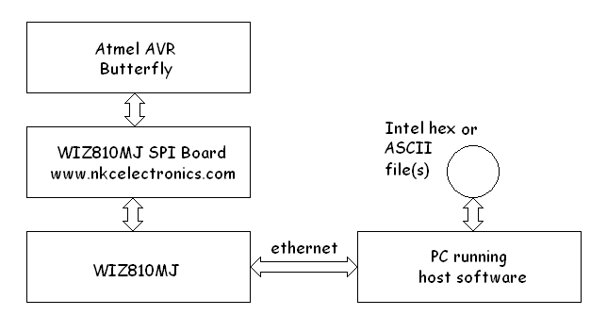
Figure 7 – Block diagram

Photographs
The photograph shows the commercial components luxuriously mounted to prevent electrical shorts and to facilitate handling. The wiring harness extends below the visible surface.
The 6 pin header in the Butterfly’s lower right corner is both its SPI and programming header (AVRs use the SPI pins for one of several methods of programming). To program the Butterfly with this application this connector is temporarily replaced with one to the programming hardware. An Atmel STK500 programmer was used, although many alternatives exist.

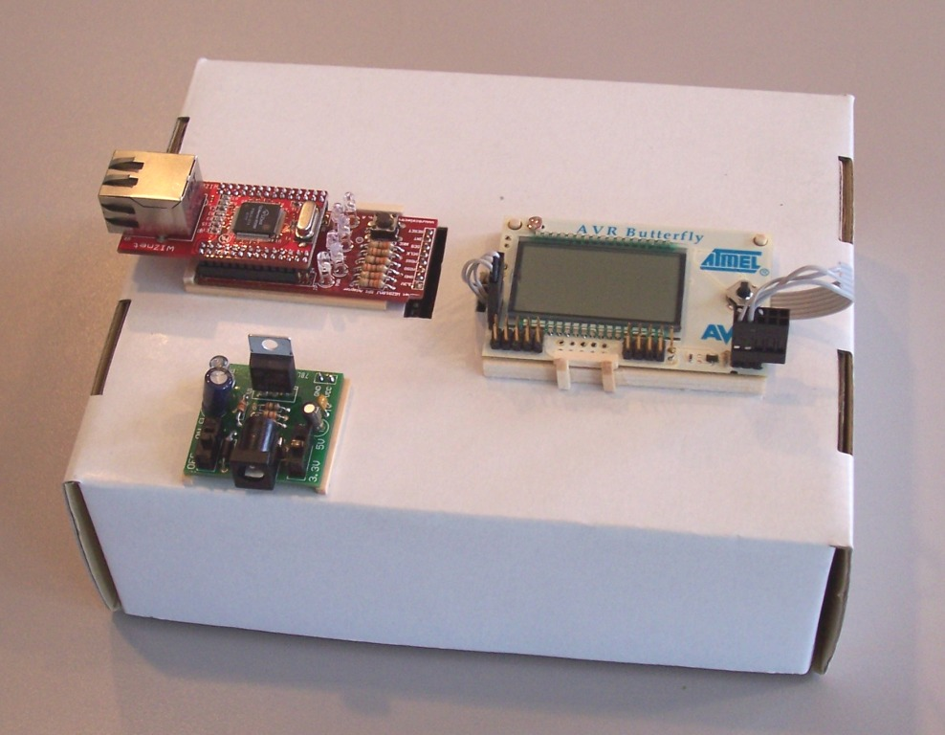
Figure 8 – Yet another use for recycled cardboard

Figure 8 clockwise, from upper left: WIZ810MJ (on top) plugged into the breakout/carrier (bottom) board, the Atmel AVR Butterfly, and the Sparkfun Breadboard Power Supply.
In Figure 9 below, the RS-232 connection coming off the left hand side of the Butterfly is not used in this application.

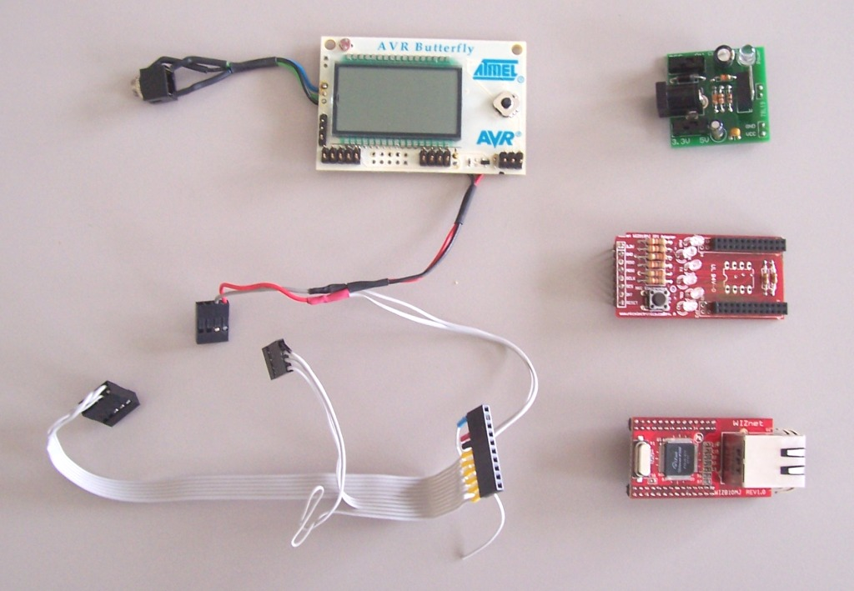
Figure 9 – Parts is parts

This harness was used because this Butterfly already had the headers soldered on. A more practical and useful approach for programming unmodified Butterflies would be a set of clip on connectors (such as cleverly modified clothes pins) which would suffice for making the necessary temporary connections.

Schematic
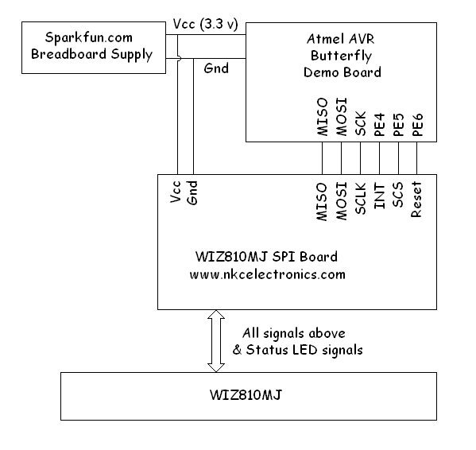
Figure 10 – Schematic

Software Code
Assembly language was used in the AVR because the author lacks better sense. All code is original, although pieces have been borrowed from other of the author’s projects (some published), including another WIZnet iEthernet Design Contest entry.
The assembler used was the one included in the (free) Atmel AVR Studio 4, which also contains the programmer interface for the STK500 board (and others). Visual Basic 6 was used for the PC host software.
Interrupts on the WIZ810MJ were not used, and all communications was conducted through polled monitoring of the status byte. Polling adds some overhead, but this application uses such a tiny fraction of the available computing power that it was irrelevant. The W5100 interrupt signal is routed to the Butterfly but not configured or utilized.

Butterfly Client Software (AVR assembly language)

There was one main source file, and one included source file. The test application is included in the main source file.

; File name: WIZnet_001153.asm
;
; Project Title: "AVR Flash Loader"

The code has been omitted to make this word document a nicer size.

PC Server Software (Visual Basic 6)
There is the main form, a form for the image editor, a form for the autoload files, and a module containing general routines and declarations.

VERSION 5.00
Object = "{248DD890-BB45-11CF-9ABC-0080C7E7B78D}#1.0#0"; "MSWINSCK.OCX"
Begin VB.Form frmWIZ_001153

The code has been omitted to make this word document a nicer size.

